Phase 1:

<!DOCTYPE html>

<html>

<head>

<title>Real-Time Transit Information</title>

<style>

/* Add your CSS styles for the platform here */

#map {

width: 100%;

height: 400px;

}

</style>

</head>

<body>

<h1>Real-Time Transit Information</h1>

<div id="map"></div>

<script>

// Replace this with actual data retrieval from IoT sensors and database

function fetchDataFromSensorsAndDatabase() {

// Simulated data for demonstration

const vehicleLocations = [

{ vehicleID: 1, lat: 40.7128, lng: -74.0060 },

{ vehicleID: 2, lat: 34.0522, lng: -118.2437 },

// Add more vehicle locations as needed

];

return vehicleLocations;

}

// Update the map with real-time vehicle locations

function updateMap() {

const map = new google.maps.Map(document.getElementById("map"), {

zoom: 10,

center: { lat: 40.7128, lng: -74.0060 }, // Default center

});

const vehicleLocations = fetchDataFromSensorsAndDatabase();

vehicleLocations.forEach((location) => {

new google.maps.Marker({

position: { lat: location.lat, lng: location.lng },

map: map,

title: `Vehicle ID: ${location.vehicleID}`,

});

});

}

// Load the Google Maps API

function loadGoogleMaps() {

const script = document.createElement("script");

script.src = "https://maps.googleapis.com/maps/api/js?key=YOUR_API_KEY&callback=updateMap";

script.defer = true;

script.async = true;

document.body.appendChild(script);

}

loadGoogleMaps();

</script>

</body>

</html>

Phase 2:

<!DOCTYPE html>

<html>

<head>

<title>Public Transportation System</title>

<style>

/* Add your CSS styles here */

</style>

</head>

<body>

<h1>Public Transportation System</h1>

<div id="routeSelector">

<label for="route">Select Route:</label>

<select id="route">

<option value="route1">Route 1</option>

<option value="route2">Route 2</option>

<!-- Add more routes as needed -->

</select>

</div>

<div id="demandFactor">

<label for="demand">Demand Factor:</label>

<input type="range" id="demand" min="1" max="10" step="1" value="5">

<span id="demandValue">5</span>

</div>

<div id="fare">

<h2>Fare: <span id="fareValue">$5.00</span></h2>

</div>

<script>

const routeSelector = document.getElementById("route");

const demandFactor = document.getElementById("demand");

const demandValue = document.getElementById("demandValue");

const fareValue = document.getElementById("fareValue");

routeSelector.addEventListener("change", updateFare);

demandFactor.addEventListener("input", updateFare);

function updateFare() {

const selectedRoute = routeSelector.value;

const selectedDemandFactor = demandFactor.value;

// You would have a more sophisticated algorithm for dynamic pricing here

// This is a simple example that multiplies the demand factor by a base fare

const baseFare = 5.00;

const fare = (baseFare * selectedDemandFactor).toFixed(2);

demandValue.textContent = selectedDemandFactor;

fareValue.textContent = `$${fare}`;

}

</script>

</body>

</html>

Phase :3

<!DOCTYPE html>

<html>

<head>

<title>Traffic Management System</title>

<!-- Include your CSS and JavaScript libraries here -->

</head>

<body>

<h1>Traffic Management System</h1>

<!-- User interface components -->

<div id="realTimeMonitoring">

<!-- Display real-time traffic information using AI and DAC -->

</div>

<div id="trafficPrediction">

<!-- Show traffic prediction data based on AI models and DAC -->

</div>

<div id="trafficSignalControl">

<!-- Control and visualize traffic signals using CAD and IoT -->

</div>

<div id="incidentManagement">

<!-- Handle incident detection and management -->

</div>

<div id="dataStorageAndReporting">

<!-- Manage historical traffic data and reporting with DAC and CAD -->

</div>

<!-- Include more components for other aspects of the system as needed -->

<!-- JavaScript to interact with the backend system and update the UI -->

<script>

// Implement JavaScript logic to interact with the backend components

// and update the user interface.

</script>

</body>

</html>

Phase :4

<!DOCTYPE html>

<html>

<head>

<meta charset="UTF-8">

<title>IoT-Based Traffic Management System Report</title>

</head>

<body>

<h1>IoT-Based Traffic Management System Report</h1>

<h2>Executive Summary</h2>

<!-- Summary content -->

<h2>1. Introduction</h2>

<!-- Introduction content -->

<h2>2. Technology Overview</h2>

<!-- Technology overview content -->

<h2>3. IoT Phase</h2>

<!-- IoT phase content -->

<h2>4. AI Phase</h2>

<!-- AI phase content -->

<h2>5. ADS Phase</h2>

<!-- ADS phase content -->

<h2>6. DAC Phase</h2>

<!-- DAC phase content -->

<h2>7. IoT Phase (Web Development)</h2>

<!-- IoT (Web Development) phase content -->

<h2>8. CAD Phase (IBM Cloud Foundry)</h2>

<!-- CAD (IBM Cloud Foundry) phase content -->

<h2>9. Results and Outcomes</h2>

<!-- Results and outcomes content -->

<h2>10. Conclusion</h2>

<!-- Conclusion content -->

<h2>11. Recommendations</h2>

<!-- Recommendations content -->

<h2>12. Appendices</h2>

<!-- Appendices content -->

<h2>13. References</h2>

<!-- References content -->

<h2>14. Acknowledgments</h2>

<!-- Acknowledgments content -->

<h2>15. Distribution</h2>

<!-- Distribution content -->

</body>

</html>

Phase 5:

<!DOCTYPE html>

<html>

<head>

<meta charset="UTF-8">

<title>Real-Time Traffic Monitoring System Report</title>

</head>

<body>

<h1>Real-Time Traffic Monitoring System Report</h1>

<h2>Project Objectives</h2>

<!-- Objectives content -->

<h2>IoT Sensor Setup</h2>

<!-- IoT sensor setup content -->

<!-- Include diagrams and schematics here -->

<h2>Mobile App Development</h2>

<!-- Mobile app development content -->

<!-- Include screenshots of the mobile app here -->

<h2>Raspberry Pi Integration</h2>

<!-- Raspberry Pi integration content -->

<!-- Include diagrams and schematics here -->

<h2>Code Implementation</h2>

<!-- Code snippets and explanations -->

<h2>Real-Time Traffic Monitoring Benefits</h2>

<!-- Explain how the system assists commuters and improves traffic flow -->

<!-- Include diagrams and screenshots showing the user interface in action -->

<h2>Conclusion</h2>

<!-- Summarize the project and its impact on traffic management -->

<h2>Appendices</h2>

<!-- Include any supplementary information, technical specifications, or additional content as needed -->

<h2>References</h2>

<!-- Cite all sources, data sets, and tools used in the project -->

<h2>Acknowledgments</h2>

<!-- Acknowledge the contributions of team members, mentors, or organizations involved in the project -->

</body>

</html>

PHASE :5 documentation part

**Project Objectives:** The project aims to enhance traffic management and commuter experience by creating a real-time traffic monitoring and management system. The objectives include:

1. **Improving Traffic Flow:** To reduce traffic congestion, minimize commute times, and optimize traffic signal timings.
2. **Enhancing Commuter Experience:** To provide real-time traffic information to commuters through a user-friendly mobile app, allowing them to make informed route decisions.
3. **Effective IoT Integration:** To deploy a network of IoT sensors, including cameras and traffic flow sensors, to collect real-time traffic data.
4. **Data Processing and Analysis:** To use Raspberry Pi devices for data processing and analysis to generate insights and control traffic signals.
5. **Mobile App Development:** To develop a mobile app that interfaces with IoT sensors and provides real-time traffic updates and recommendations to commuters.

**IoT Sensor Setup:** The project includes the deployment of various IoT sensors at critical locations within the traffic network. These sensors collect real-time traffic data, including vehicle counts, speed, and congestion. The sensor setup involves a combination of cameras for video surveillance and traffic flow sensors embedded in the road infrastructure.

**Mobile App Development:** The development of a mobile app is a key component of the project. The app is designed to provide commuters with real-time traffic information and assist them in making optimal route decisions. Features of the app include real-time traffic updates, congestion alerts, route recommendations, and user-friendly interfaces for input and interaction.

**Raspberry Pi Integration:** Raspberry Pi devices are integrated into the system to process and analyze data collected by IoT sensors. They serve as data processing hubs, running algorithms for traffic analysis and control. Raspberry Pi devices communicate with traffic signals to optimize signal timings based on real-time traffic conditions.

**Code Implementation:** The project's code implementation includes:

1. Code for IoT Sensors: To collect and transmit traffic data from sensors to the central processing unit.
2. Code for Data Analysis: To process, analyze, and interpret the data collected from IoT sensors.
3. Mobile App Development: Code for the mobile app that interfaces with IoT sensors and provides a user-friendly experience.
4. Raspberry Pi Code: To run algorithms for data analysis, control traffic signals, and make real-time traffic adjustments.

The code is implemented using relevant programming languages and frameworks, ensuring seamless communication between IoT sensors, data processing components, and the mobile app. It plays a critical role in making the real-time traffic monitoring and management system functional and efficient.

By achieving these objectives, the project aims to create a system that not only improves traffic flow and reduces congestion but also enhances the overall commuter experience by providing them with accurate and timely information for making optimal route decisions.

DIAGRAMANTIC REPRESNTATION:

SEM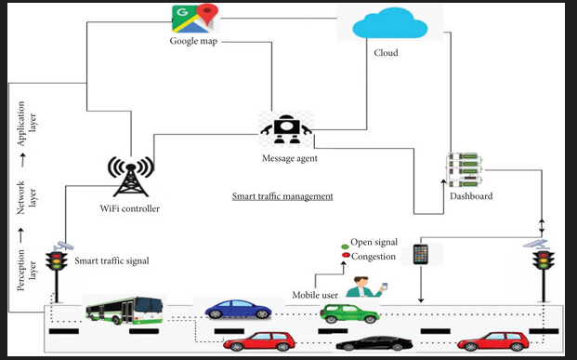ANT

Top of Form

SEMANTIC REPRESNTATION 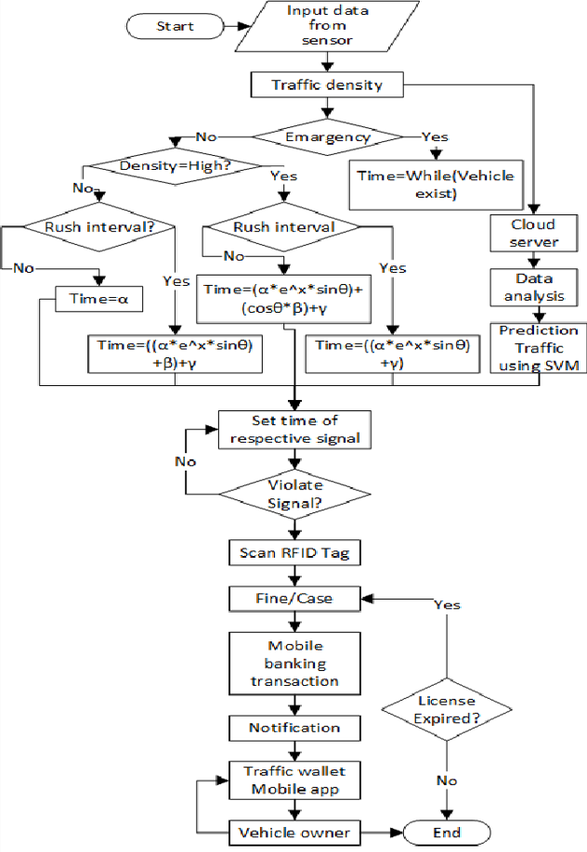

DESIGN:

